Blog
Tales of Harmony: The journey of “ALTERCATION”
13th March 24 | Mehedi Hasan Rowdro

Music holds a special place in the hearts of many, myself included. It has always been a source of immense passion and inspiration for me. Today, I am excited to share the story of my band, ALTERCATION.

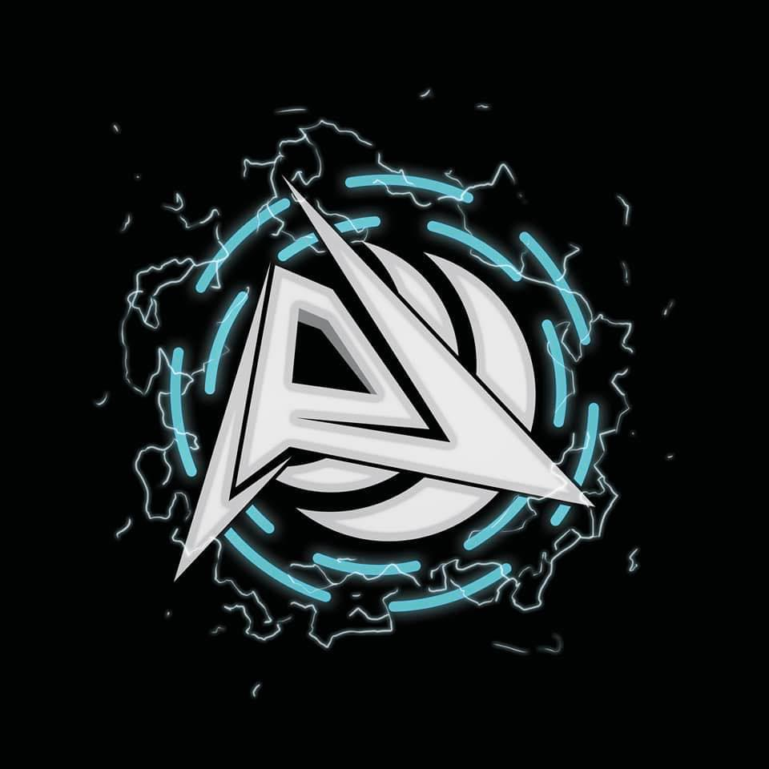

The logo of ALTERCATION

It all started back in 2018, during my 9th-grade year, when I developed a deep interest in learning the guitar. After many requests, my mother finally agreed to buy me my first guitar, an acoustic guitar. With this instrument in hand, I embarked on a journey to fulfill my dream of forming a band.

The initial steps towards this dream were challenging. While learning the guitar from a tutor, I met Raj, a friend who shared my musical aspirations. Together, we had the idea of forming a band. With our shared passion, we set out to find other members who shared our musical vision.

By the year 2020, after much perseverance, we managed to gather a group of individuals to form our band, ALTERCATION. Saad bhai joined us as the vocalist, while Tamim bhai, Rahul, and I took on the guitar roles. Badhon took responsibility for the drums, and Raj took the bass guitar part. With six members, we began our musical journey.

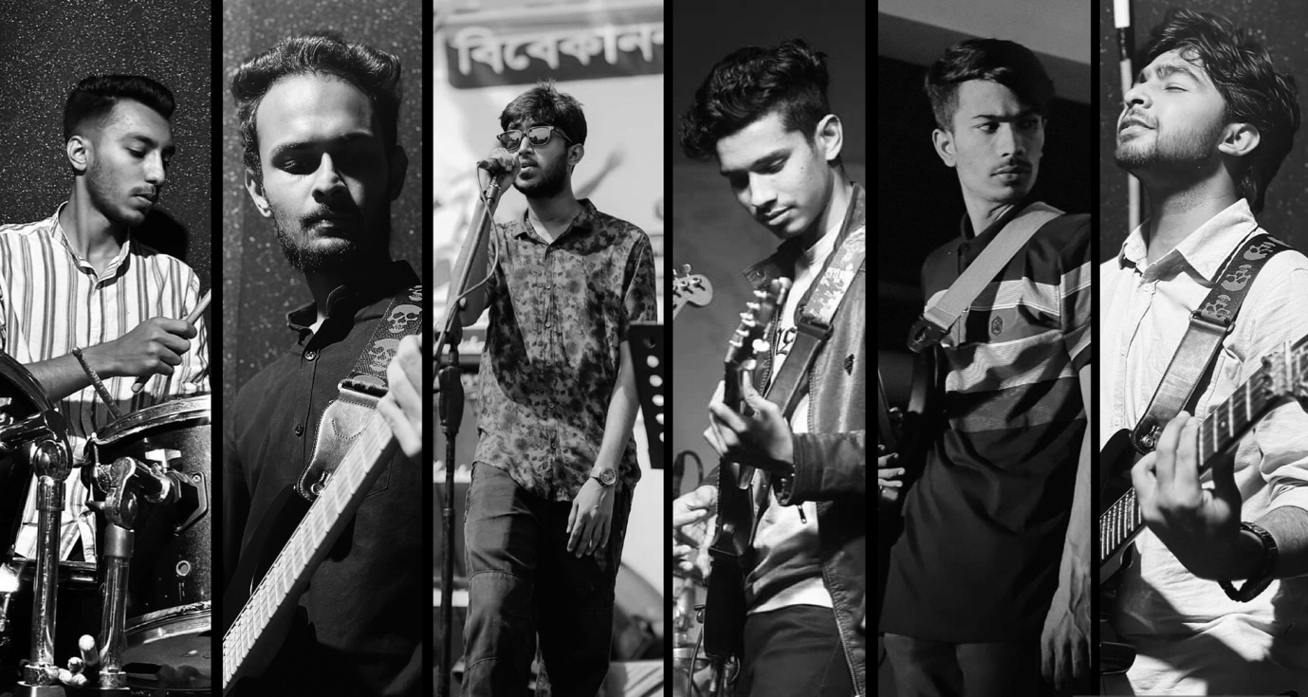

ALTERCATION band members

Our initial rehearsals were filled with excitement as we explored various musical genres and styles. We spent many hours refining our skills and experimenting with different sounds. Despite our dedication, one challenge we faced was choosing a name for our band. After much thought, we settled on ALTERCATION, symbolizing our collective mission to fight negativity through our music.

As we solidified our identity as ALTERCATION, we transformed a normal practice room into our creative sanctuary. Decorated with posters and soundproofing materials, this space became where we poured our hearts and souls into our music.
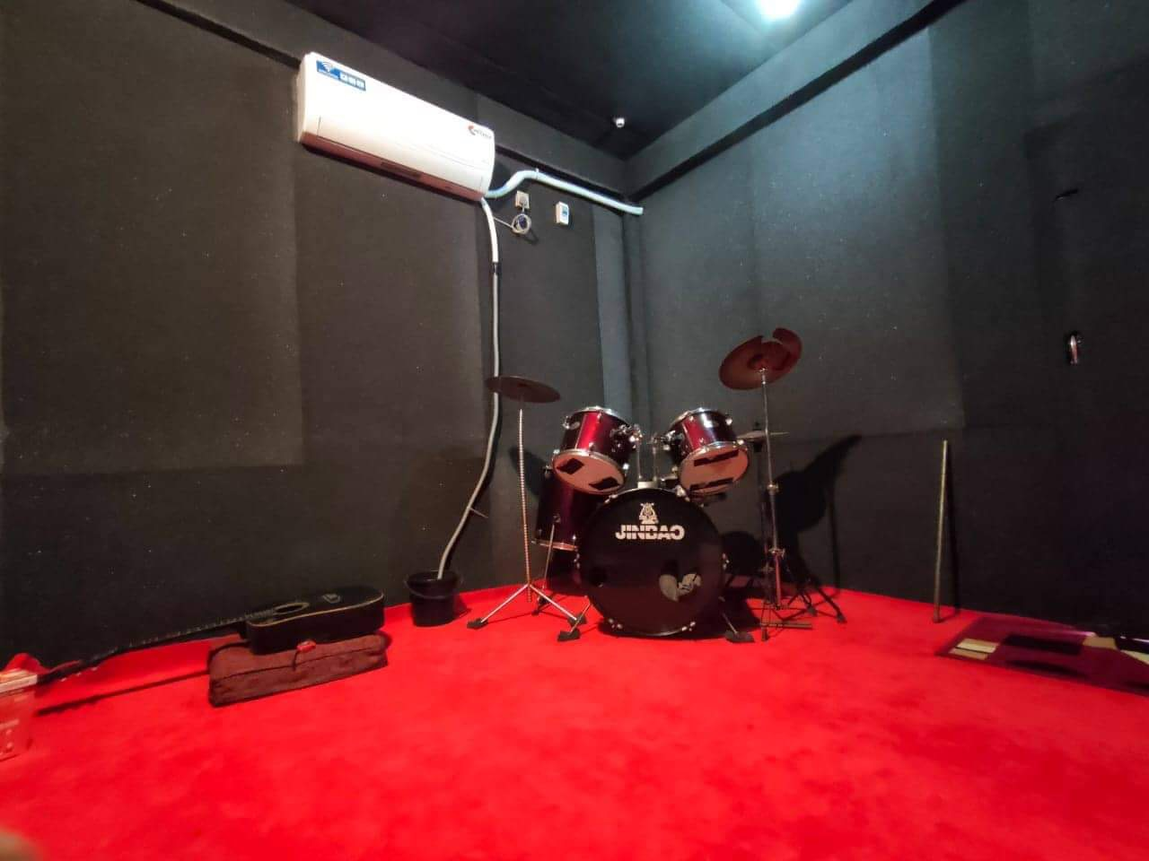

Our Practice room

Our efforts soon paid off as we began performing at local venues and events in our town. With each performance, we received praise and recognition from our peers and the community. However, our aspirations went beyond cover songs and live performances. Driven by a desire for creative expression, we started composing our own music.

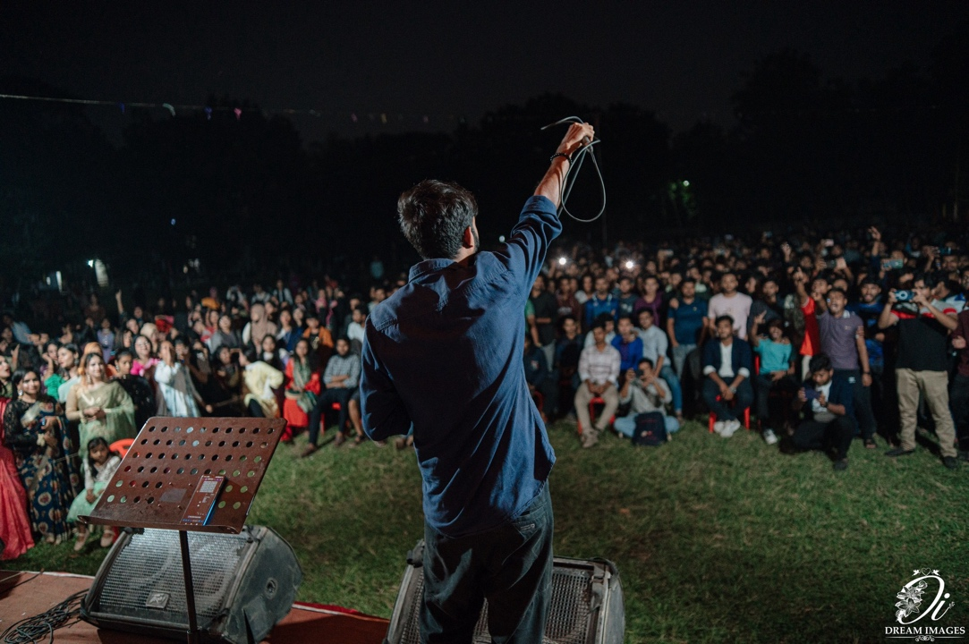

A glimps of one of our concerts

Despite facing numerous obstacles, including academic and personal responsibilities, we remained commited to our band. Slowly but steadily, our original compositions took shape. Today, we stand on the edge of releasing our first album, a testament to our dedication and passion for music.

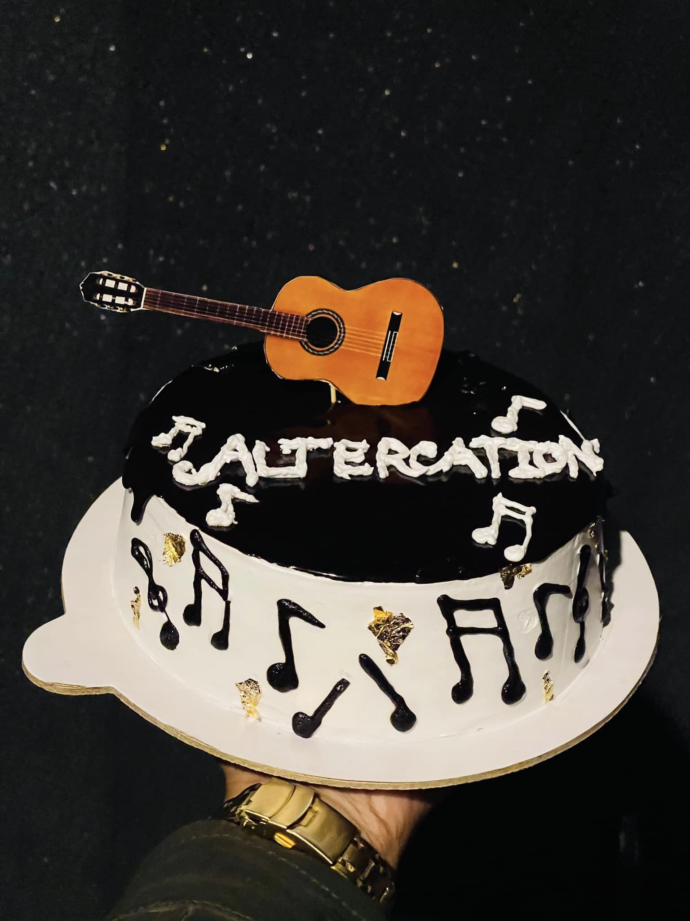

Celebrating the 1-year anniversary of the formation of our band

As we think about our journey with ALTERCATION, we are grateful for the experiences and opportunities that music has brought us. While our path may be filled with challenges and uncertainties, we remain steadfast in our commitment to pursuing our dreams. With each note we play and each song we write, we move one step closer to making a lasting impact on the world of music.

In conclusion, the story of ALTERCATION highlights the transformative power of music and the limitless potential of human creativity. As we continue our musical journey, we remain hopeful and determined, knowing that our passion for music will guide us through whatever challenges lie ahead.

